**Cracked window in Boeing aircraft's cockpit forces All Nippon Airways flight to return**

"The cabin pressure of the Boeing 737-800 aircraft was normal and the landing was made under normal conditions," the airline said of Saturday's flight.

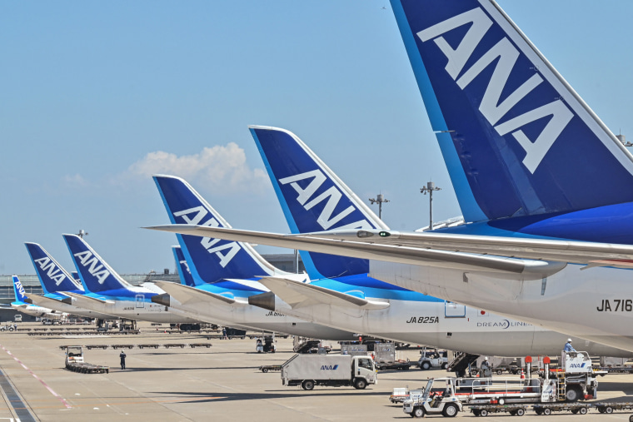

A line of All Nippon Airways planes at Tokyo International Airport.Richard A. Brooks / AFP via Getty Images

Jan. 15, 2024, 10:38 AM PST

By [Elizabeth Chuck](https://www.nbcnews.com/author/elizabeth-chuck-ncpn341)

An All Nippon Airways flight that departed from Sapporo's New Chitose Airport in Japan on Saturday returned after a crack was discovered in the cockpit window of [the Boeing aircraft](https://www.nbcnews.com/news/us-news/alaska-airlines-panel-blowout-boeing-ceo-acknowledges-mistake-rcna133198), the airline said.

Flight NH1182 "experienced a crack on one of the outermost of the four layers of the cockpit window," ANA said in an email Monday. "During the flight the cabin pressure of the Boeing 737-800 aircraft was normal and the landing was made under normal conditions."

No other aircraft in the fleet were affected, the airline said, adding, "The safety of our passengers and flight crew is our priority and we apologize for the inconvenience."

The crack was discovered about 40 minutes after takeoff of the flight, which was headed to Toyama Airport.

Boeing declined to comment on the cracked window, which happened just over a week after a [startling accident](https://www.nbcnews.com/news/us-news/alaska-airlines-flight-makes-emergency-landing-part-plane-appears-deta-rcna132618) involving one of its 737 Max airplanes in the U.S. In that mishap, [a door plug fell off](https://www.nbcnews.com/news/us-news/alaska-airlines-flight-makes-emergency-landing-part-plane-appears-deta-rcna132618) a Max 9 while the plane was in the air, leaving a hole in the side and forcing an emergency landing.

There were no serious injuries on the Alaska Airlines flight. The Federal Aviation Administration has grounded Boeing 737 Max 9 airplanes equipped with the door plugs for safety checks and [has opened an investigation](https://www.nbcnews.com/news/us-news/faa-investigate-boeing-door-plug-falls-alaska-airlines-plane-midair-rcna133491) into Boeing.

On Monday, the CEO of Boeing’s commercial airplanes division, Stan Deal, sent an email to employees [pledging additional inspections](https://www.nbcnews.com/news/us-news/boeing-says-taking-hard-look-quality-control-alaska-airlines-accident-rcna133940) after the Alaska Airlines accident.

Unlike the Max, Boeing's newest 737 model, the 737-800 aircraft flown by ANA has been in service for over two decades. A popular plane around the world, the 737-800 is known for its reliability and safety record.